Sam McDowell

7/2/2020

Lab 2.1C

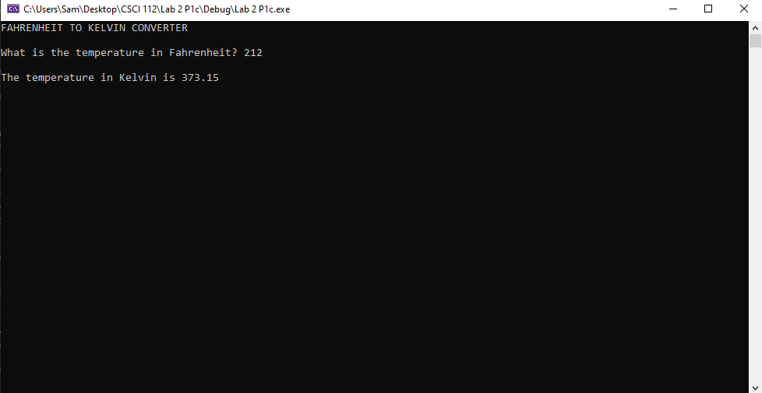

# Transcription:

FAHRENHEIT TO KELVIN CONVERTER

What is the temperature in Fahrenheit? 212

The temperature in Kelvin is 373.15